**LAPORAN AKHIR PRAKTIKUM**

Mata praktikum : SISTEM BASIS DATA 2

Kelas : 3IA11

Praktikum ke- : 4

Tanggal : 10/05/2025

Materi : DATABASE SYSTEM TOOLS/ DATABASE MANAGEMENT SYSTEM

Npm : 51422161

Nama : MUHAMMAD TARMIDZI BARIQ

Ketua asisten : Muhammad Yasin

Jumlah lembar : 11



**LABORATORIUM TEKNIK INFORMATIKA**

**UNIVERSITAS GUNADARMA**

**2025**

1. table users

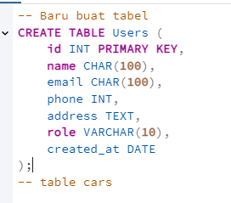

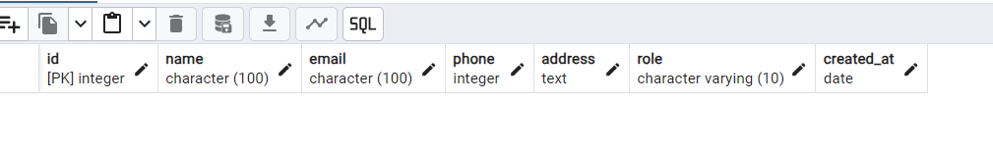

2. table cars

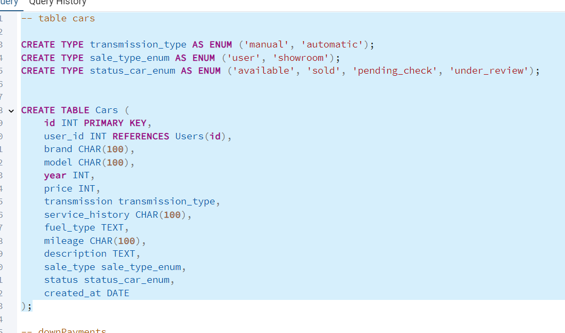

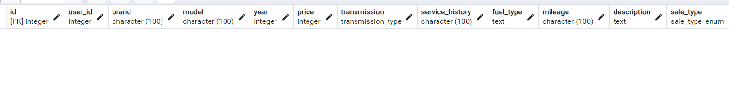

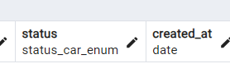

3.

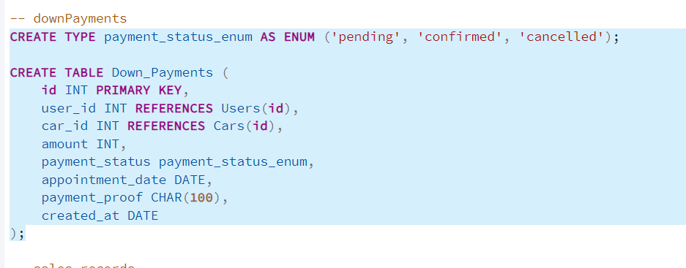

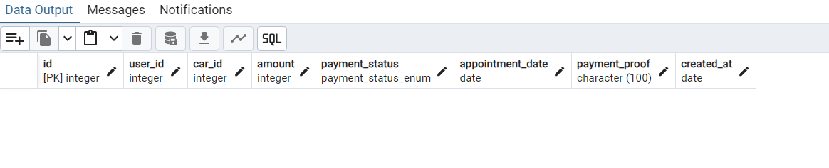

4. sales records

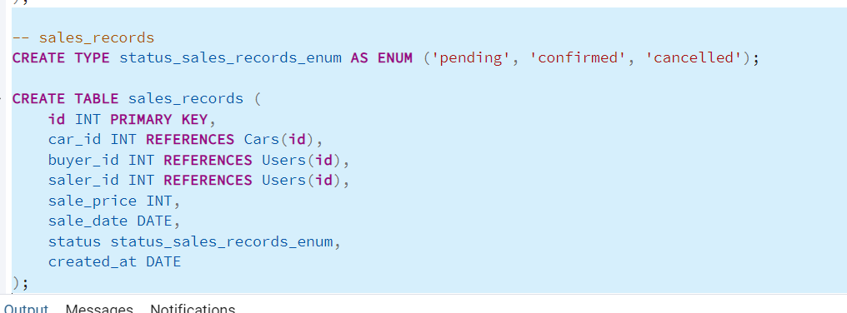

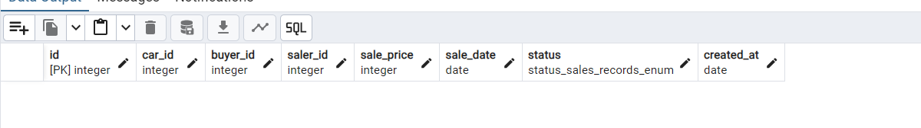

5. reviews

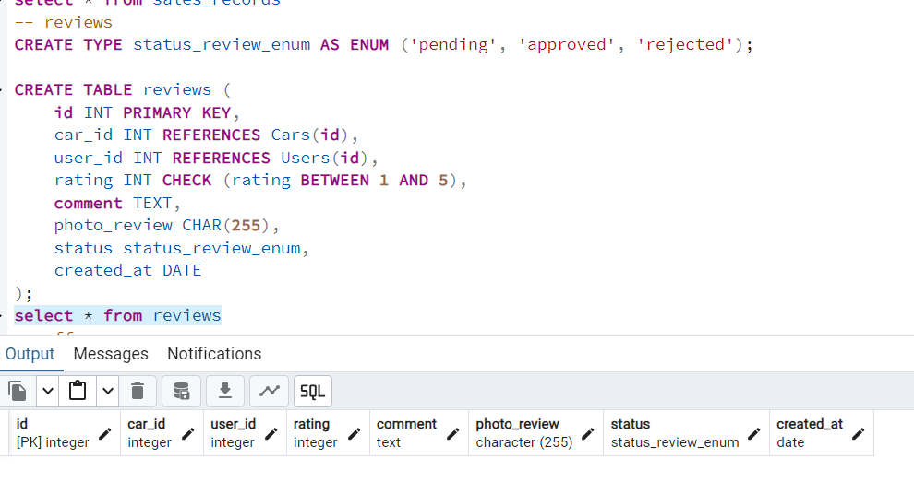

6. offers

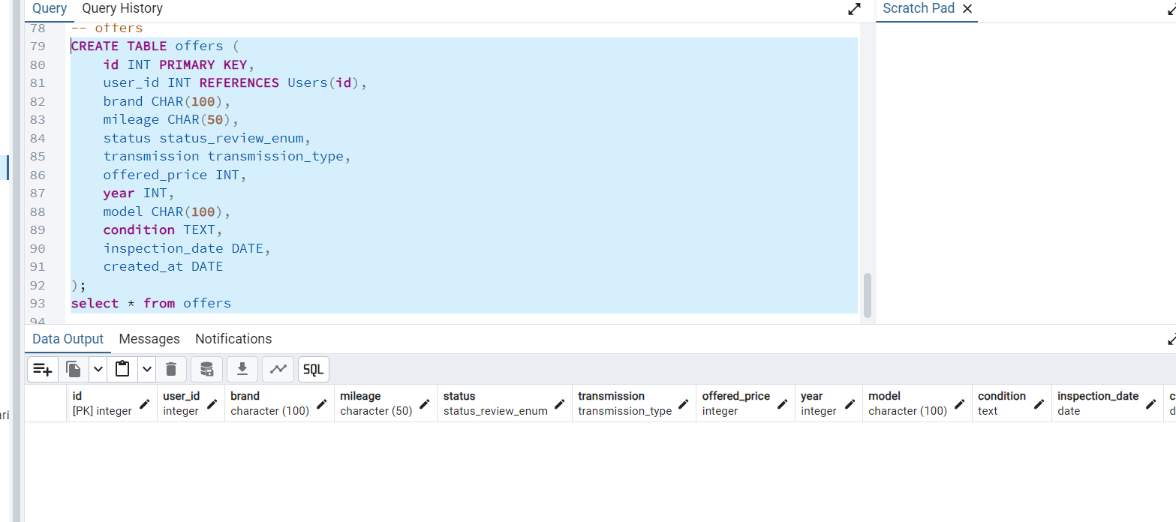

7. full code

-- TABEL USERS

CREATE TABLE Users (

id INT PRIMARY KEY,

name CHAR(100),

email CHAR(100),

phone INT,

address TEXT,

role VARCHAR(10),

created_at DATE

);

-- table cars

CREATE TYPE transmission_type AS ENUM ('manual', 'automatic');

CREATE TYPE sale_type_enum AS ENUM ('user', 'showroom');

CREATE TYPE status_car_enum AS ENUM ('available', 'sold', 'pending_check', 'under_review');

CREATE TABLE Cars (

id INT PRIMARY KEY,

user_id INT REFERENCES Users(id),

brand CHAR(100),

model CHAR(100),

year INT,

price INT,

transmission transmission_type,

service_history CHAR(100),

fuel_type TEXT,

mileage CHAR(100),

description TEXT,

sale_type sale_type_enum,

status status_car_enum,

created_at DATE

);

-- downPayments

CREATE TYPE payment_status_enum AS ENUM ('pending', 'confirmed', 'cancelled');

CREATE TABLE Down_Payments (

id INT PRIMARY KEY,

user_id INT REFERENCES Users(id),

car_id INT REFERENCES Cars(id),

amount INT,

payment_status payment_status_enum,

appointment_date DATE,

payment_proof CHAR(100),

created_at DATE

);

-- sales_records

CREATE TYPE status_sales_records_enum AS ENUM ('pending', 'confirmed', 'cancelled');

CREATE TABLE sales_records (

id INT PRIMARY KEY,

car_id INT REFERENCES Cars(id),

buyer_id INT REFERENCES Users(id),

saler_id INT REFERENCES Users(id),

sale_price INT,

sale_date DATE,

status status_sales_records_enum,

created_at DATE

);

select * from sales_records

-- reviews

CREATE TYPE status_review_enum AS ENUM ('pending', 'approved', 'rejected');

CREATE TABLE reviews (

id INT PRIMARY KEY,

car_id INT REFERENCES Cars(id),

user_id INT REFERENCES Users(id),

rating INT CHECK (rating BETWEEN 1 AND 5),

comment TEXT,

photo_review CHAR(255),

status status_review_enum,

created_at DATE

);

select * from reviews

-- offers

CREATE TABLE offers (

id INT PRIMARY KEY,

user_id INT REFERENCES Users(id),

brand CHAR(100),

mileage CHAR(50),

status status_review_enum,

transmission transmission_type,

offered_price INT,

year INT,

model CHAR(100),

condition TEXT,

inspection_date DATE,

created_at DATE

);

select * from offers

8. insert data users

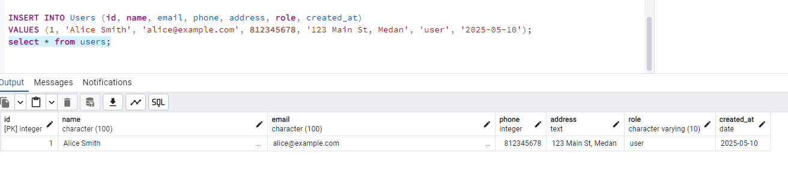

9. insert data cars

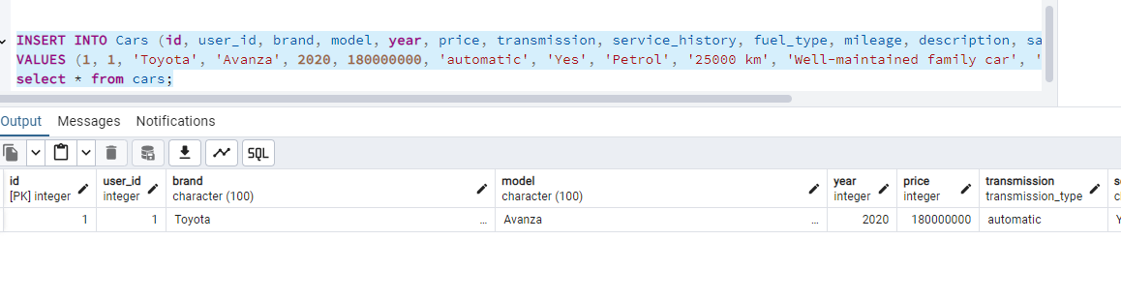

10. insert data down_payments

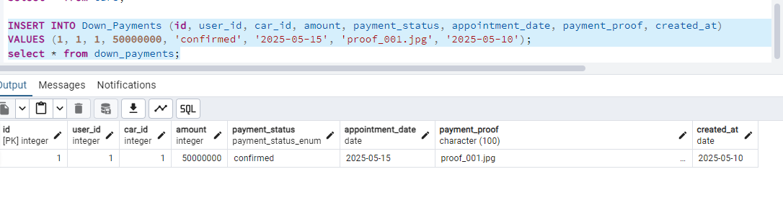

11. insert data sales_record

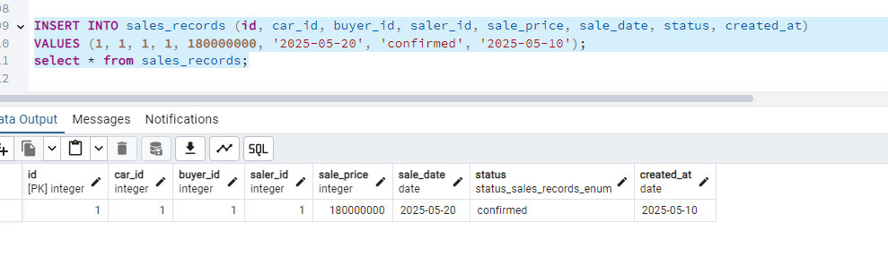

12. reviews

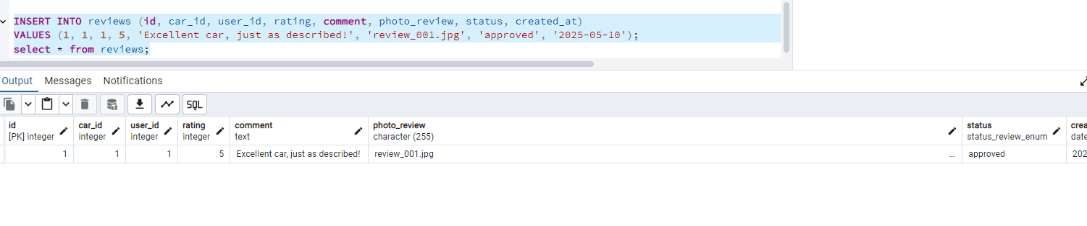

13. offers

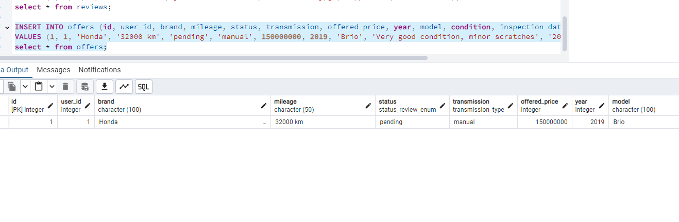

14. code data insert

INSERT INTO Users (id, name, email, phone, address, role, created_at)

VALUES (1, 'Alice Smith', 'alice@example.com', 812345678, '123 Main St, Medan', 'user', '2025-05-10');

select * from users;

INSERT INTO Cars (id, user_id, brand, model, year, price, transmission, service_history, fuel_type, mileage, description, sale_type, status, created_at)

VALUES (1, 1, 'Toyota', 'Avanza', 2020, 180000000, 'automatic', 'Yes', 'Petrol', '25000 km', 'Well-maintained family car', 'showroom', 'available', '2025-05-10');

select * from cars;

INSERT INTO Down_Payments (id, user_id, car_id, amount, payment_status, appointment_date, payment_proof, created_at)

VALUES (1, 1, 1, 50000000, 'confirmed', '2025-05-15', 'proof_001.jpg', '2025-05-10');

select * from down_payments;

INSERT INTO sales_records (id, car_id, buyer_id, saler_id, sale_price, sale_date, status, created_at)

VALUES (1, 1, 1, 1, 180000000, '2025-05-20', 'confirmed', '2025-05-10');

select * from sales_records;

INSERT INTO reviews (id, car_id, user_id, rating, comment, photo_review, status, created_at)

VALUES (1, 1, 1, 5, 'Excellent car, just as described!', 'review_001.jpg', 'approved', '2025-05-10');

select * from reviews;

INSERT INTO offers (id, user_id, brand, mileage, status, transmission, offered_price, year, model, condition, inspection_date, created_at)

VALUES (1, 1, 'Honda', '32000 km', 'pending', 'manual', 150000000, 2019, 'Brio', 'Very good condition, minor scratches', '2025-05-12', '2025-05-10');

select * from offers;